- To begin this project open Tinker CAD in your desired browser. You will log in and open a new workspace. This program is a beginner 3D modeling software intended to make basic shapes. It is also a great basic program to begin making laser cutting templates.

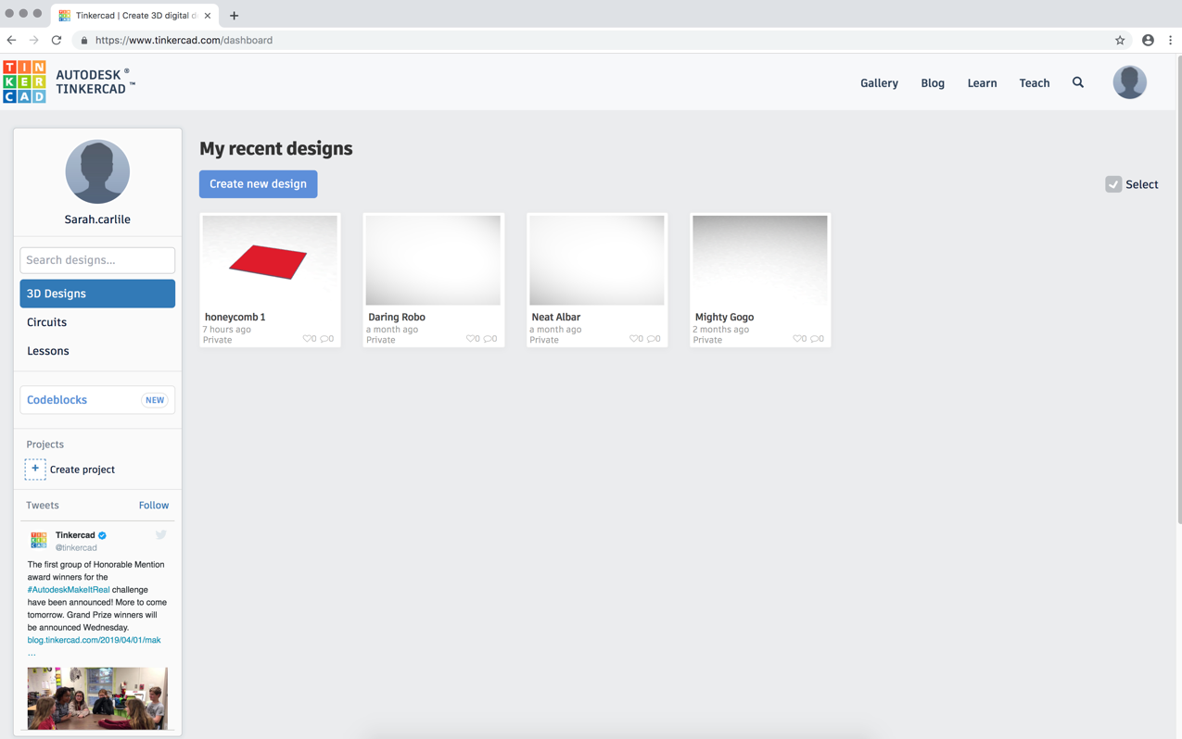

- Once you are in a new workspace you can rename it to fit what we will be working on. your work space will look like the image below before we start.

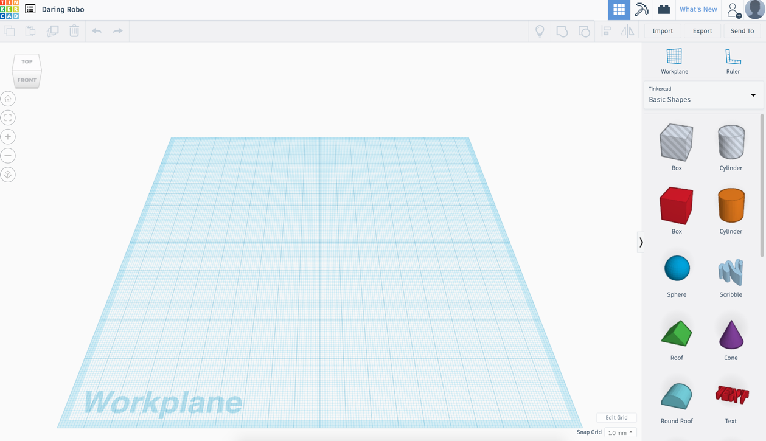

Notice the tools in the top left-hand corner of the work space. You can change your view of the workspace by moving the cube. The house will bring you back you the original view, the second button will zoom into the piece currently selected, the plus and minus will enlarge or shrink the amount of the workspace you see, and the last button will flatten your view.
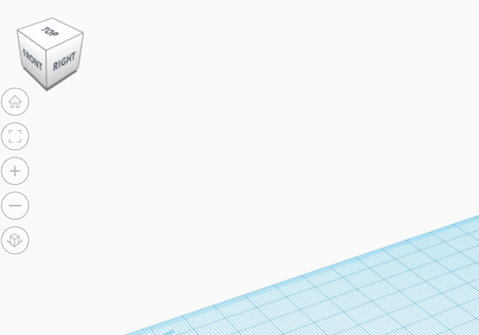

- Adjust your work plane. First, we will switch from millimeters to inches to more appropriately size our work. Then we will need to make a larger work plane. For this project we will be cutting BFK paper that is 30” x 22” so we will make our plane that large.

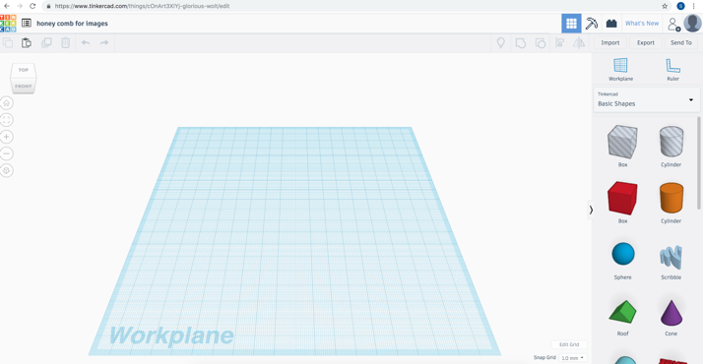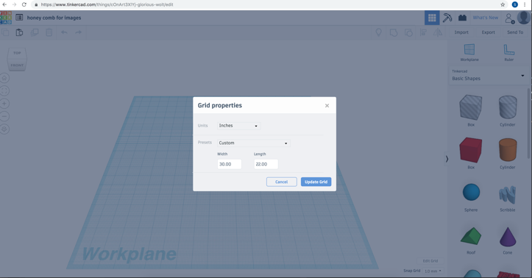

Edit grid and work plane here.

- Option 1
Drag the scribble icon onto your workspace to draw a freehand shape or design. This screen will pop up and you are ready to begin drawing you design! After hitting done in the bottom right hand corner you can adjust the size just like we did with the cube. (repeat step 4.)
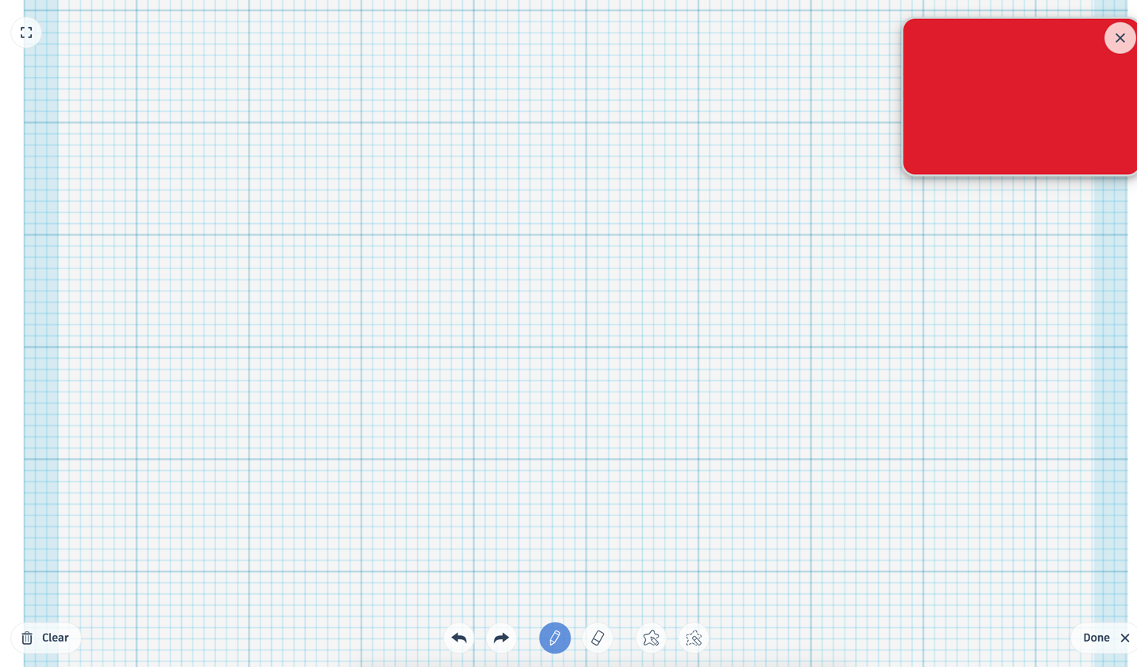

Your Drawing will look something like this as you work on it.

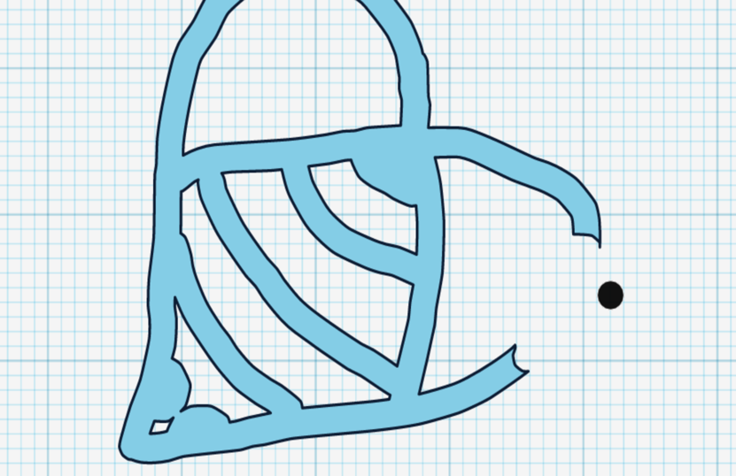

- Option 2.
You can drag in some of the other shapes in the panel on the right to create a more geometric texture pad. That would look more like the image below when finished.

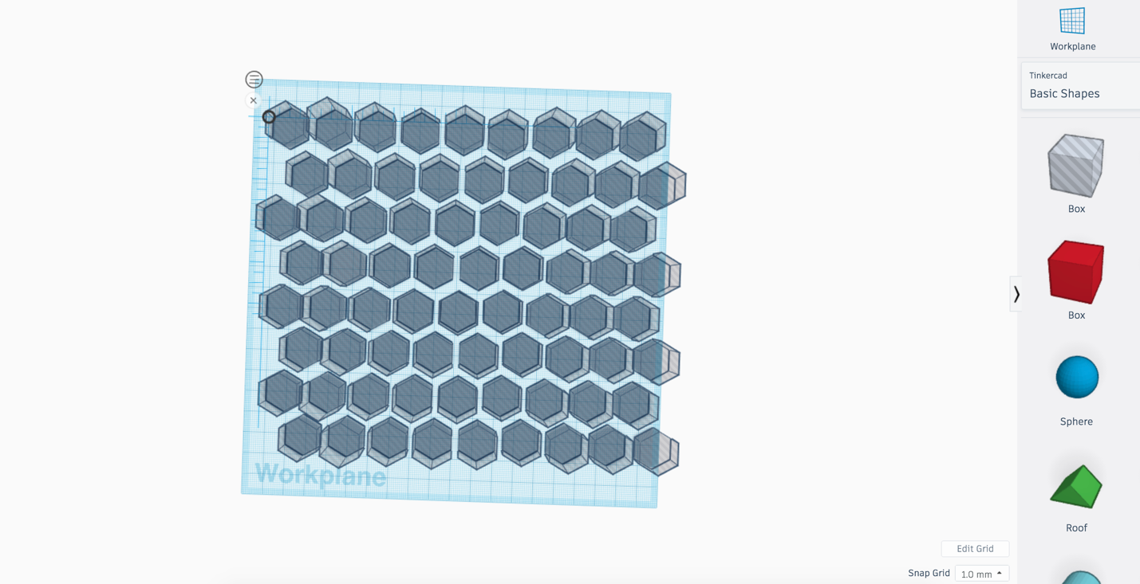

- Since we are making stencils, you will need to make sure all of your shapes go into the negative on their height and are marked as a hole in the program.

- Once you have finished your drawing or geometric shape it needs to be repeated. Click on your shape so the program knows what you want to work with. Hit Control + c (PC) or Command + c (MAC) to copy your image and Control + v (PC) or Command + v (MAC) to paste it again. Re position the new image to make 2 next to each other. Repeat until you have a full row. (This does not have to be an even row, if your pattern would work better staggered, flipped, or in some other configuration that is okay.)

- While holding down the left button on your mouse draw a box around the row to select them all at once. This will group the images together so you can move them all at once. There is also a button in the top left for this.

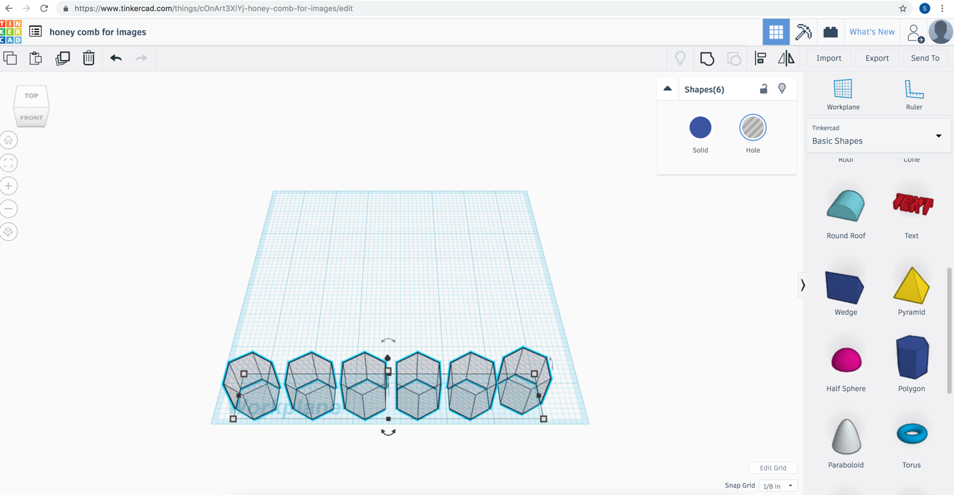

- Once you have the images all grouped together copy and paste them to fill the area. (The size of the square can be adjusted slightly to accommodate the shapes.) Be sure to move the rows as you paste them because they only stay grouped until they are placed.
- At this point you will need to double check that all of your images are holes that go all the way through, and the same height and depth.

- Once you are happy with your design for your stencil you must export it from tinker cad and import it into Illustrator. To export just hit the export button in the top right corner of Tinker CAD and save as an SVG file. Open illustrator and open the file. 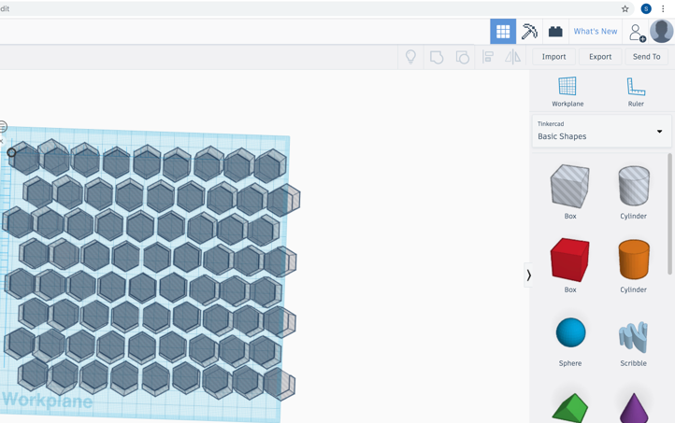 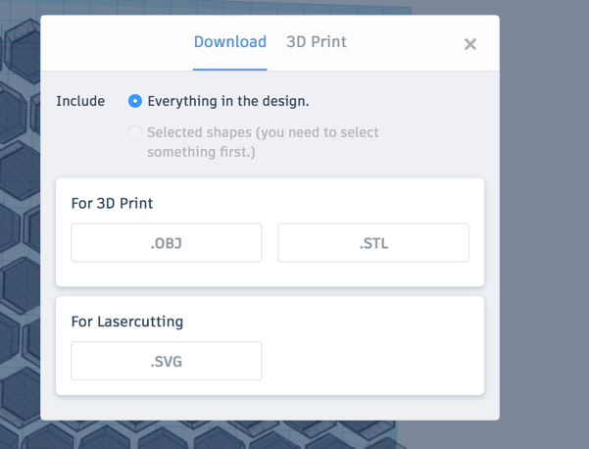
Your Illustrator screen should look like this when you open your file from tinker CAD.
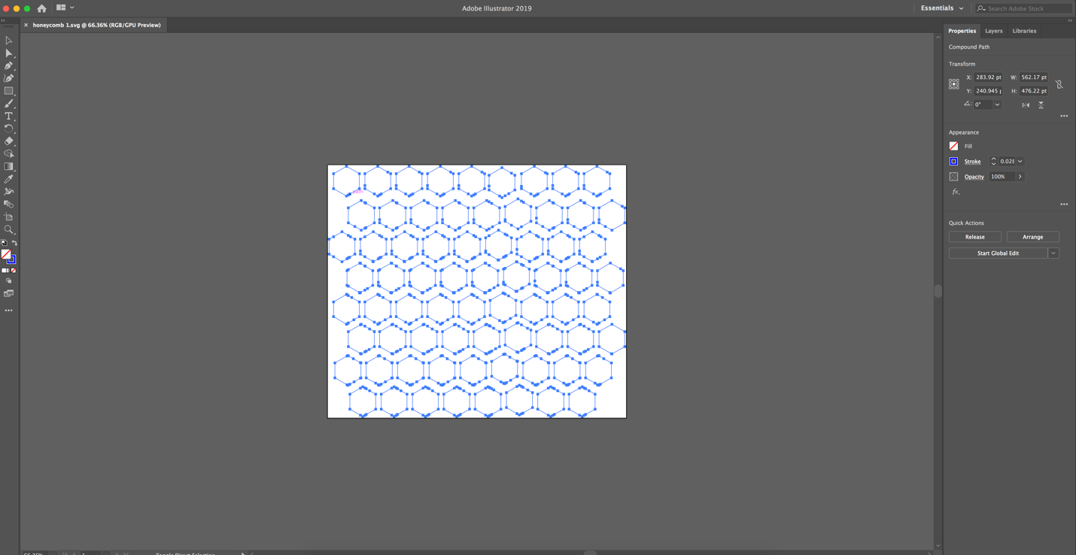

- Holding down the left button on the mouse in the select tool draw a square around the entire board. Adjust the size of the lines to be .001 thickness.
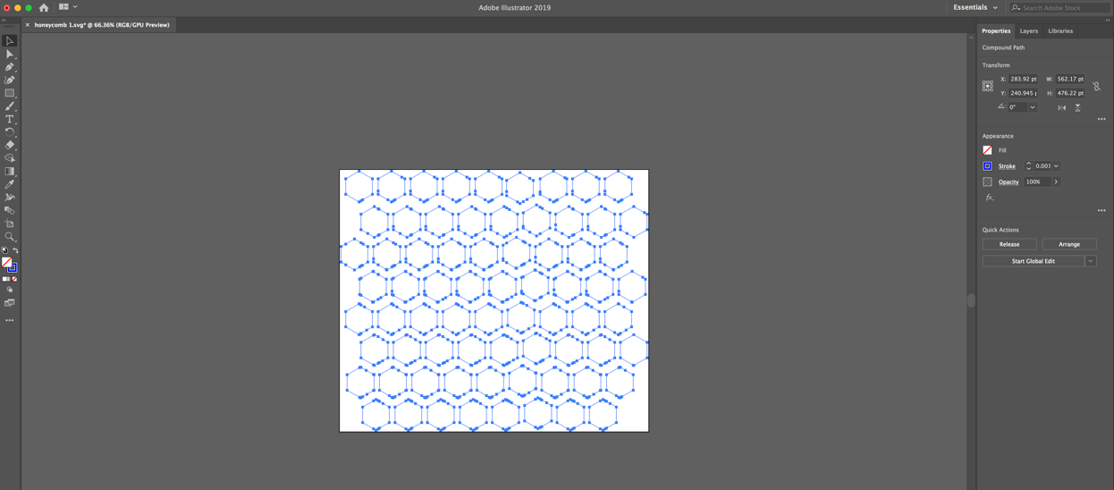

Once you have all lines at a .001 thickness you are ready to cut!

