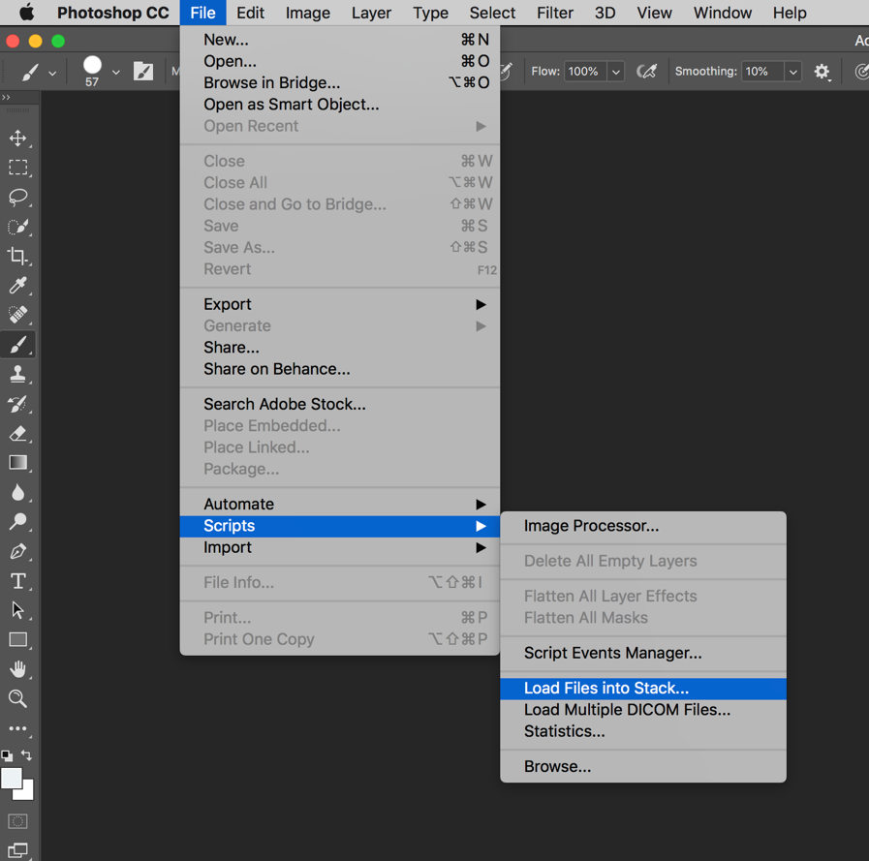
1. To begin making your photo Gif open a new canvas on photoshop. You will need to have at least 2 images saved to your computer, however they can be the same image saved under 2 names. Select file > Scripts > Load files into Stack…
2. In the load layers screen choose “Browse” and select your images. Hold down shift while clicking on your images to select multiple at once.

Because this is a photo Gif each frame of the Gif is a separate photo. For this option you will need only one image but several frames, so we are going to duplicate your original image into multiple layers. This can either be done all at once before you begin, or as you go if you are going to be adding onto your drawing as you go.
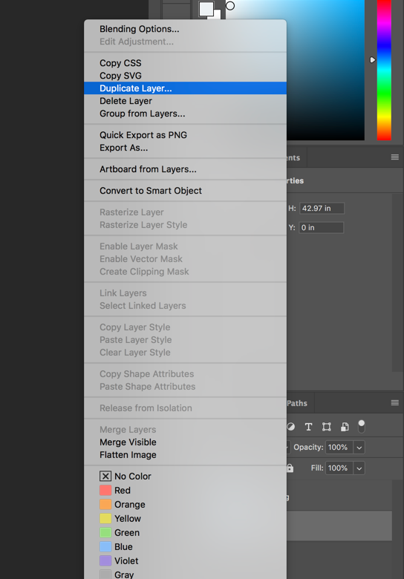
3. To create several layers of the same image right click on the layer you want to duplicate and select “duplicate Layer…”. Rename each time so you know where this image belongs ex. “layer 5”.

Now It’s time to get creative! Spend some time drawing in your interaction with the image you chose. Some examples of how you might do this is by drawing in a type of weather, an animal, or showing something moving across the image. We have learned about several ways to edit our images throughout the semester and this is your opportunity to use some of the cool things you have learned!
4. We are asking that for this option you draw in something that moves or interacts with the image that you chose. To draw on top of your image you will select the paint brush tool. You may need to adjust your brush, you can do this by selecting the white circle icon in the top menu. You can adjust the size of your brush with the first sliding bar, and the hardness with the second sliding bar. Below that are a variety of preset brushes you can choose from.
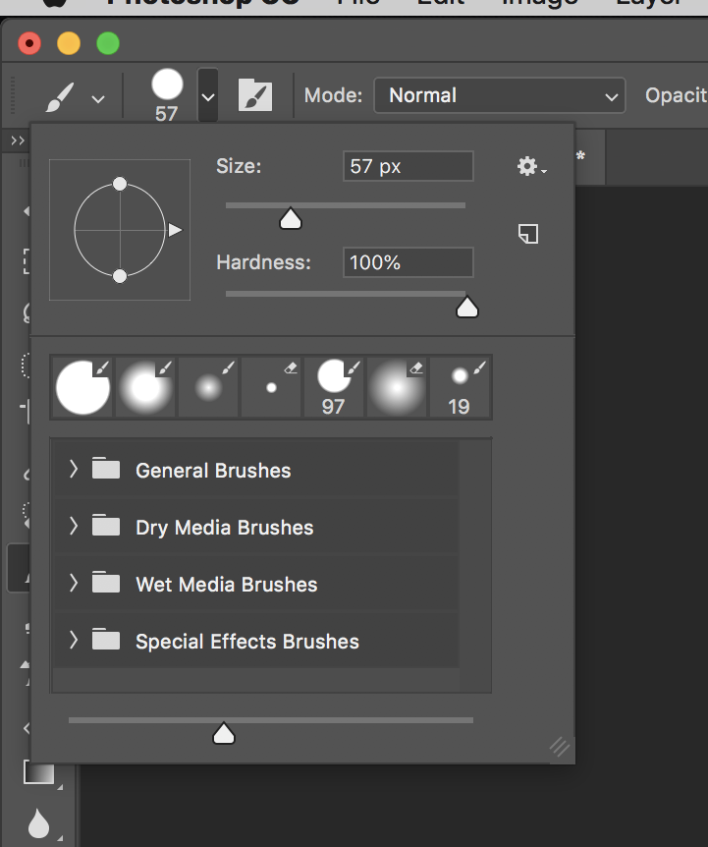

Make sure as you are drawing on each layer that you are drawing on the correct layer. Since we are not changing the transparency, make sure you are using the eye icon to the left of each layer so you only have the layer you are currently working on visible.

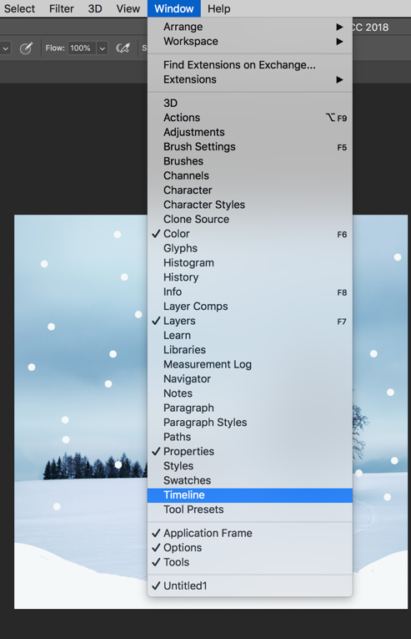 Your timeline box should appear below your workspace. It can be moved by clicking and dragging the tab (where it says timeline) above the window, it will highlight in blue where it going to be placed.
5. Once you are happy with all of your drawing it’s time to turn them into a Gif! If you do not have the “timeline” window already open in your work space you will need to open it. Go to the “Windows” menu at the top and select “Timeline”.
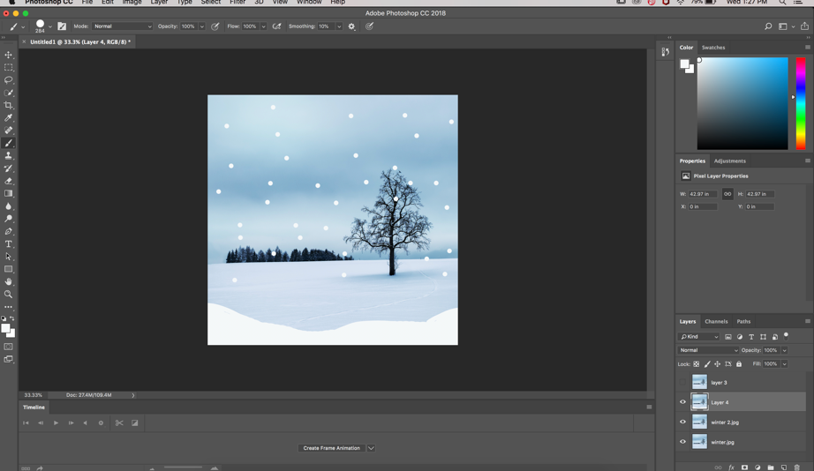
Timeline tab

6. In the middle of the “timeline” window click on the drag down window and select “Create Frame Animation”. Click on this box again (not the drag down menu just the box) to create your first frame.

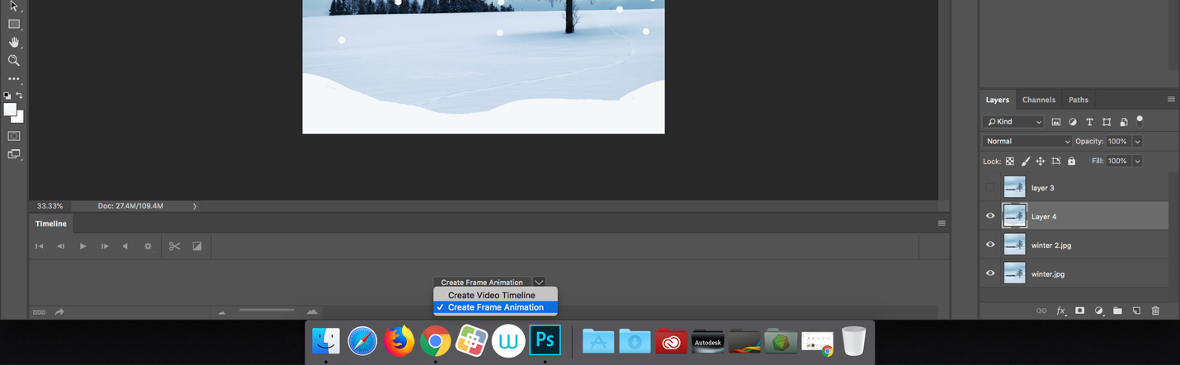

7. To create the rest of your flames click on the menu bar on the righthand side of the “timeline” window (4 little lines) and select “Make Frames from Layer”. This will turn each layer you have into its own frame in your Gif.

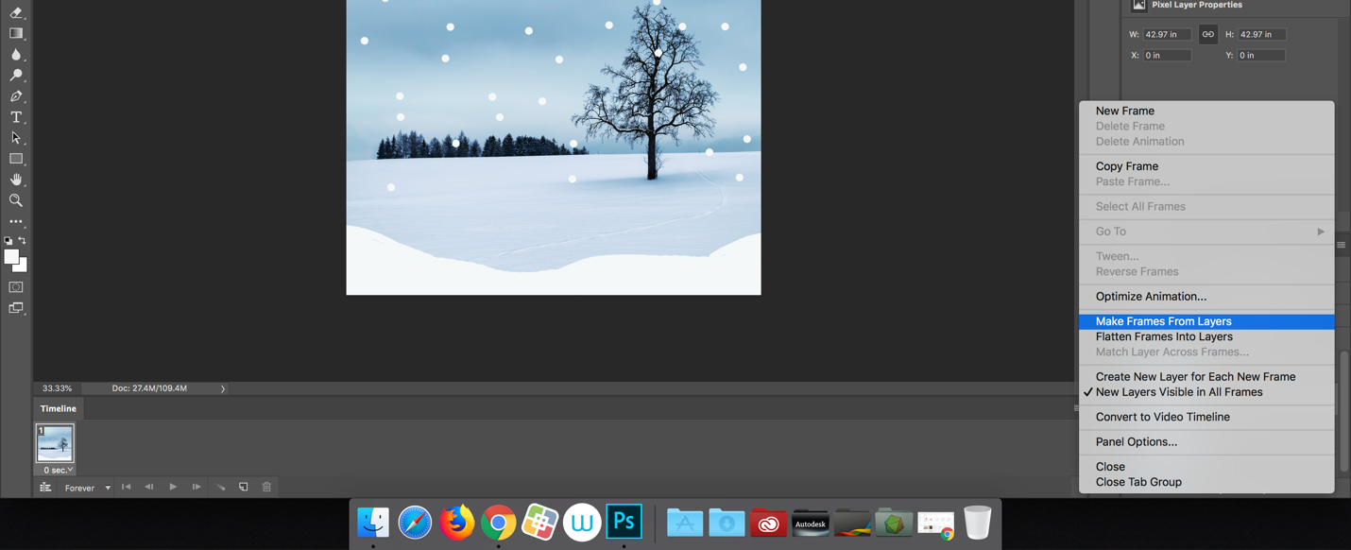
Menu bar

8. Now that all your layers have been made into frames you might notice that they are each set for 0 seconds of play time. To change this, hold down the “shift” button and click on the first and last frames, this will select all of your frames at once. On the first frame click on the time drop down menu and select how long each frame should show, for my examples I chose 1 second each. You can choose longer or shorter and it doesn’t have to be the same for each frame.

Test out your Gif by playing it here.
Delete unwanted frames here.

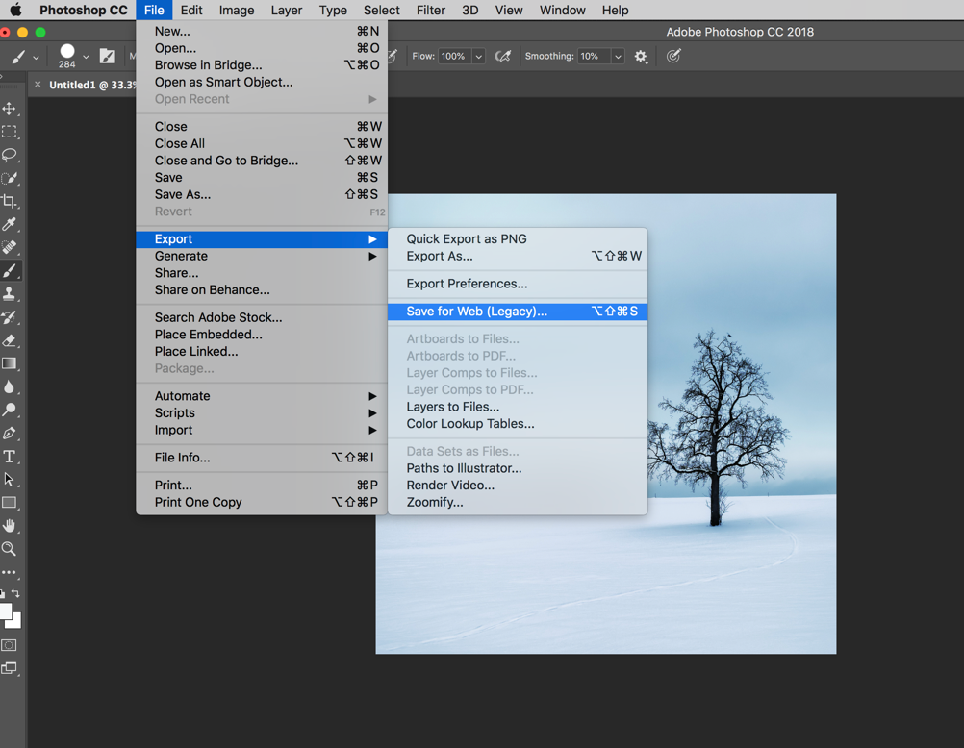
9. When you are happy with your Gif it’s time to export. You will select

File > Export > Safe for Web

10. This screen will pop up to save your Gif
Must be saved as a Gif

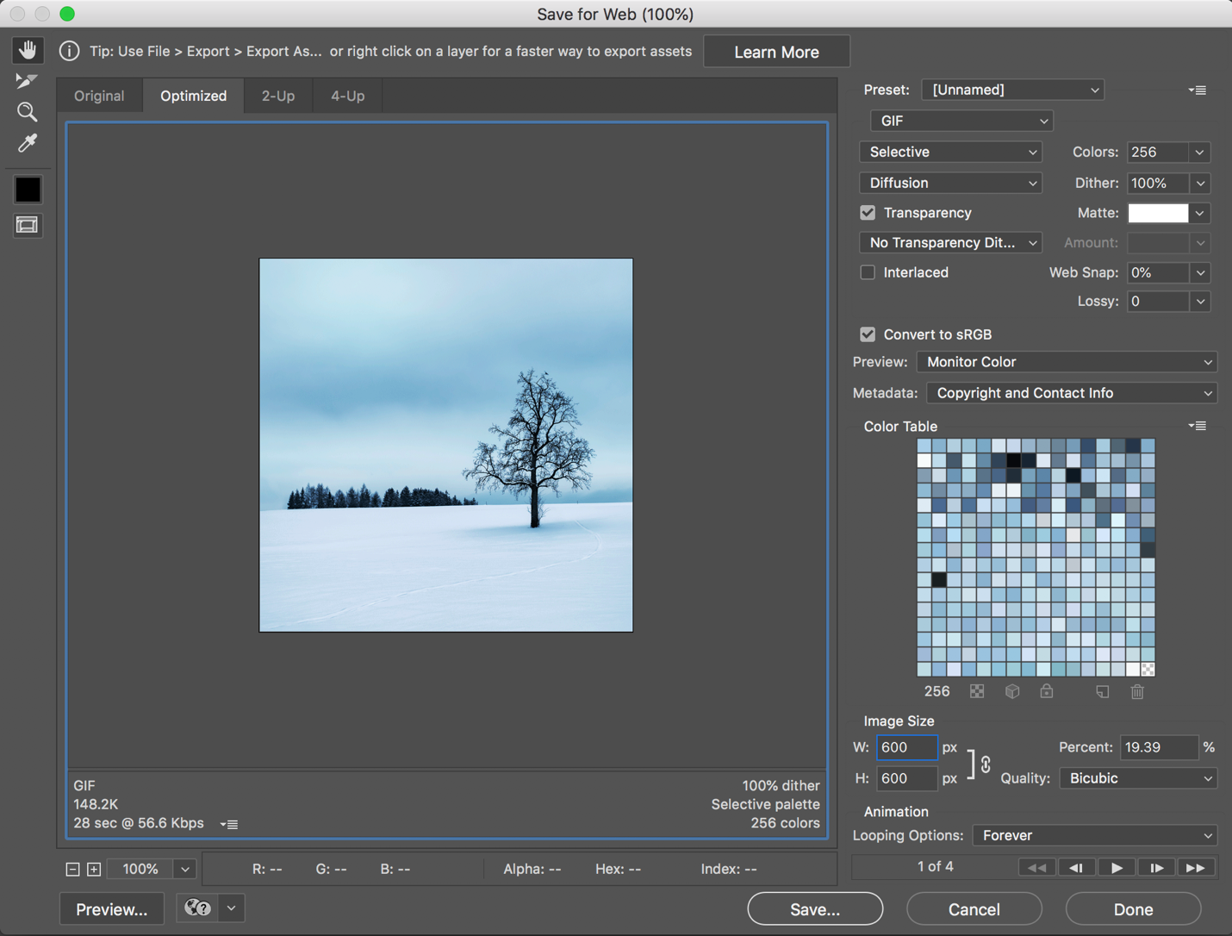
The size should be fairly small

11. Hit save and you are all set!

For additional help view my screen cast here https://www.youtube.com/watch?v=khpXH5xvAUk

